**COMPUTER NETWORK**

**UNIT .1**

A **computer network** is a system in which multiple computers are connected to each other to share information and resources

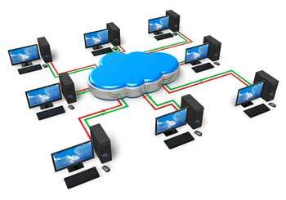

**Characteristics of a Computer Network**

* Share resources from one computer to another.
* Create files and store them in one computer, access those files from the other computer(s) connected over the network.
* Connect a printer, scanner, or a fax machine to one computer within the network and let other computers of the network use the machines available over the network.

**Following is the list of hardware's required to set up a computer network.**

* Network Cables
* Distributors
* Routers
* Internal Network Cards
* External Network Cards

**Network Cables**

Network cables are used to connect computers. The most commonly used cable is Category 5 cable RJ-45.

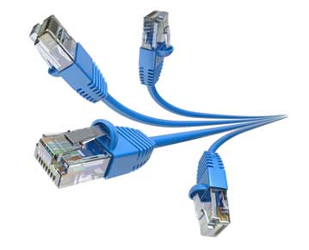

## Distributors

A computer can be connected to another one via a serial port but if we need to connect many computers to produce a network, this serial connection will not work.

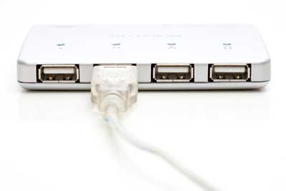

The solution is to use a central body to which other computers, printers, scanners, etc. can be connected and then this body will manage or distribute network traffic.

## Router

A router is a type of device which acts as the central point among computers and other devices that are a part of the network. It is equipped with holes called ports. Computers and other devices are connected to a router using network cables. Now-a-days router comes in wireless modes using which computers can be connected without any physical cable.

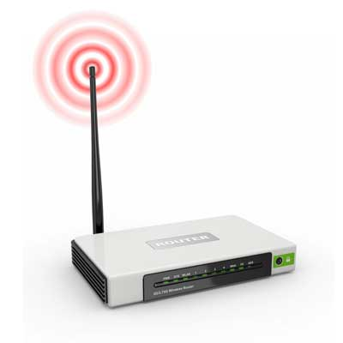

## Network Card

Network card is a necessary component of a computer without which a computer cannot be connected over a network. It is also known as the network adapter or Network Interface Card (NIC). Most branded computers have network card pre-installed. Network cards are of two types: Internal and External Network Cards.

### Internal Network Cards

Motherboard has a slot for internal network card where it is to be inserted. Internal network cards are of two types in which the first type uses Peripheral Component Interconnect (PCI) connection, while the second type uses Industry Standard Architecture (ISA). Network cables are required to provide network access.

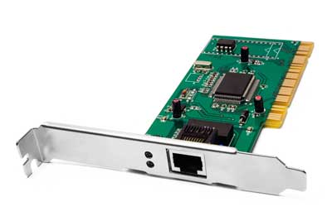

### External Network Cards

External network cards are of two types: Wireless and USB based. Wireless network card needs to be inserted into the motherboard, however no network cable is required to connect to the network.

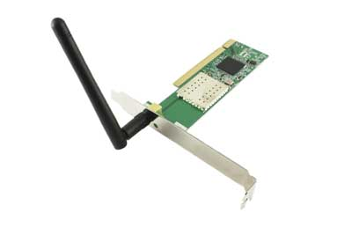

## Universal Serial Bus (USB)

USB card is easy to use and connects via USB port. Computers automatically detect USB card and can install the drivers required to support the USB network card automatically.

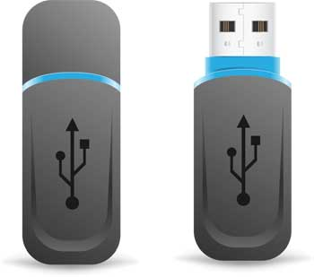

# Evolution of Computer Networks

The term [*computer*](https://ecomputernotes.com/fundamental/introduction-to-computer/what-is-computer)*networks*resulted from the ‘combination of two major areas, namely *computers*and*communications.* 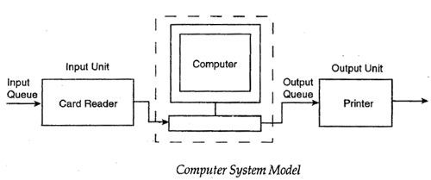

 It was during the 1950’s, that computers were treated as large complex machines and were operated by specially trained people. Jobs were given to computers in the form of batches. Punched cards, paper tapes, or magnetic tapes were used as [input devices](https://ecomputernotes.com/fundamental/input-output-and-memory/list-various-input-and-output-devices). There was no direct communication or interaction between the user and the [computer](https://ecomputernotes.com/fundamental/introduction-to-computer/what-is-computer). Users suffered with extremely long delays between the submission of jobs and the receipt of output results. The computer model resembles the one shown in Figure. Note that there are two queues, one at the input device and another at the [output device](https://ecomputernotes.com/fundamental/input-output-and-memory/list-various-input-and-output-devices).

In the 1960’s, interactive terminals were developed. Remote users can be connected to a large [mainframe](https://ecomputernotes.com/fundamental/introduction-to-computer/mainframe) computer via a low speed data line. The network resembles the one shown in Figure.

When more devices are’ connected to a computer, it is not so economical to have a separate communication line from each device to the computer. To solve this problem, multiplexers and concentrators were developed. These devices collect the output from a set of peripheral devices and send it over a common communication link. Special communication processors called *front-ends*were developed to relieve the [mainframe](https://ecomputernotes.com/fundamental/introduction-to-computer/mainframe) computers from performing all the communication functions.

Time-sharing systems were developed and that led to the development of many applications centered on a single computer. The concept of a large-scale, general-purpose network was developed. Such a network consists of a set of nodes called *network switches*or *interface message processors*(IMP) connected by means of interconnecting transmission links. Interconnecting links can be a wire, microwave radio, optical fiber, or satellite communication links. Nodes are located at geographically separated locations. Each node forwards the message passing through it to the next node in the concerned path.

# Computer networking

## Benefits of computer networks

Setting up a **computer network** is a fast and reliable way of sharing information and resources within a business. It can help you make the most of your IT systems and equipment.

### Advantages of computer networking

Main benefits of networks include:

* **File sharing** - you can easily share data between different users, or access it remotely if you keep it on other connected devices.
* **Resource sharing** - using network-connected peripheral devices like printers, scanners and copiers, or sharing software between multiple users, saves money.
* **Sharing a single internet connection** - it is cost-efficient and can help protect your systems if you properly secure the network.
* **Increasing storage capacity** - you can access files and multimedia, such as images and music, which you store remotely on other machines or network-attached storage devices.

Networking computers can also help you **improve communication**, so that:

* staff, suppliers and customers can share information and get in touch more easily
* your business can become more efficient - eg networked access to a common database can avoid the same data being keyed multiple times, saving time and preventing errors
* staff can deal with queries and deliver a better standard of service as a result of sharing customer data

### Cost benefits of computer networking

Storing information in one centralised database can also help you **reduce costs** and **drive efficiency**. For example:

* staff can deal with more customers in less time since they have shared access to customer and product databases
* you can centralise network administration, meaning less IT support is required
* you can cut costs through sharing of peripherals and internet access

You can **reduce errors** and **improve consistency** by having all staff work from a single source of information. This way, you can make standard versions of manuals and directories available to them, and back up data from a single point on a scheduled basis, ensuring consistency.

**DATA SIGNAL:- Data signal** is a method of how information is transferred; usually it's transferred in [binary](https://www.computerhope.com/jargon/b/binary.htm) code in signals or pulses and may be contained in a [packet](https://www.computerhope.com/jargon/p/packet.htm).

An **analog** or **analogue signal** is any continuous **signal** for which the time varying feature (variable) of the **signal** is a representation of some other time varying quantity, i.e., analogous to another time varying **signal**. It differs from a digital **signal** in terms of small fluctuations in the **signal** which are meaningful.

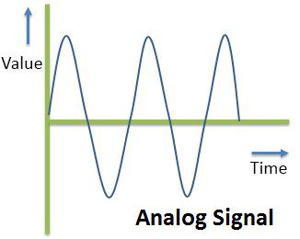

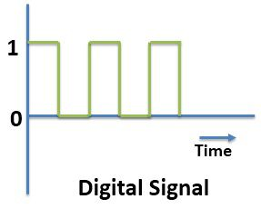

|  |  |
| --- | --- |
| **Difference Between Analog And Digital Signal** | |
| Analog Signals | Digital Signals |
| Continuous signals | Discrete signals |
| Represented by sine waves | Represented by square waves |
| Human voice, natural sound, analog electronic devices are few examples | Computers, optical drives, and other electronic devices |
| Continuous range of values | Discontinuous values |
| Records sound waves as they are | Converts into a binary waveform. |
| Only be used in analog devices. | Suited for digital electronics like computers, mobiles and more. |

**Bandwidth:**- **The maximum amount of data transmitted over an internet connection in a given amount of time.**

Bandwidth is often mistaken for internet speed when it's actually the volume of information that can be sent over a connection in a measured amount of time – calculated in megabits per second (Mbps).

**How much bandwidth do I need?**

If you have multiple devices and several family members on them at the same time, you'll need more bandwidth to keep up. Streaming, gaming and other high-capacity activities demand a certain amount of bandwidth speed to get the best experience without a lot of buffering or lag. And the more bandwidth your internet provider is able to deliver, the faster you’ll get to do your thing.

### How bandwidth works

The more bandwidth a data connection has, the more data it can send and receive at one time. Bandwidth can be compared to the amount of water that can flow through a water pipe. The bigger the pipe, the more water can flow through it at one time.

**DATA TRANSMISSION:-COMMUNTION MODES**

# Transmission Modes in Computer Networks (Simplex, Half-Duplex and Full-Duplex)

Transmission mode means transferring of data between two devices. It is also known as communication mode. Buses and networks are designed to allow communication to occur between individual devices that are interconnected. There are three types of transmission mode:-

• **Simplex Mode**

• **Half-Duplex Mode**

• **Full-Duplex Mode**

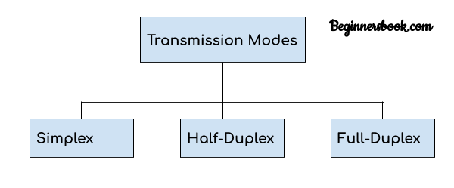  
There are three modes of [transmission](https://teachcomputerscience.com/data-transmission/), namely: simplex, half duplex, and full duplex.  The transmission mode defines the direction of signal flow between two connected devices.

The primary difference between three modes of transmission is that in asimplex mode of transmission the communication is unidirectional, or one-way; whereas in the half duplex mode of transmission the communication is two-directional, but the channel is interchangeably used by both of the connected devices.  On the other hand, in the full duplex mode of transmission, the communication is bi-directional or two-way, and the channel is used by both of the connected devices simultaneously.

### Comparison Chart

### Simplex

In simplex transmission mode, the communication between sender and receiver occurs in only one direction.  The sender can only send the data, and the receiver can only receive the data.  The receiver cannot reply to the sender.

Simplex transmission can be thought of as a one-way road in which the traffic travels only in one direction—no vehicle coming from the opposite direction is allowed to drive through.

To take a keyboard / monitor relationship as an example, the keyboard can only send the input to the monitor, and the monitor can only receive the input and display it on the screen.  The monitor cannot reply, or send any feedback, to the keyboard.

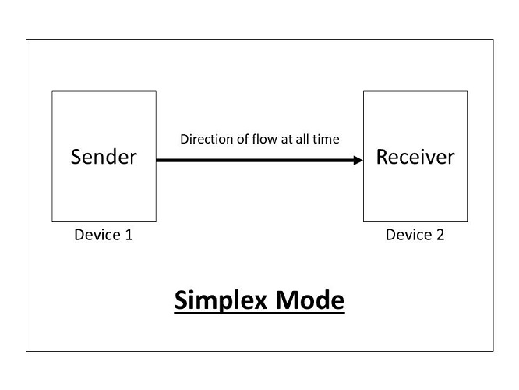

### Half Duplex

The communication between sender and receiver occurs in both directions in half duplex transmission, but only one at a time.  The sender and receiver can both send and receive the information, but only one is allowed to send at any given time.  Half duplex is still considered a one-way road, in which a vehicle traveling in the opposite direction of the traffic has to wait till the road is empty before it can pass through.

For example, in walkie-talkies, the speakers at both ends can speak, but they have to speak one by one.  They cannot speak simultaneously.

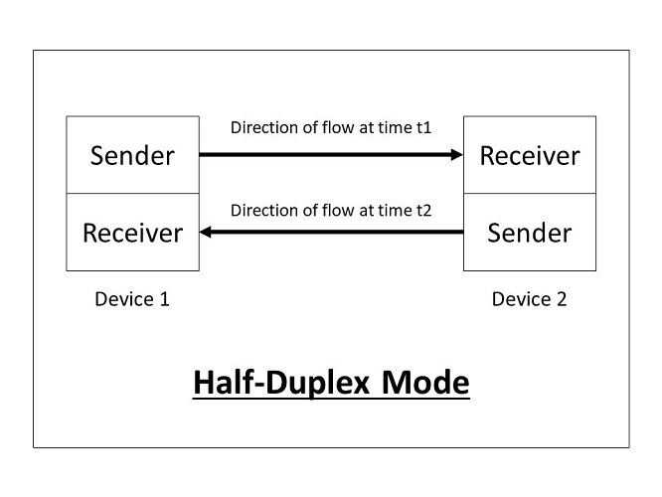Full Duplex

In full duplex transmission mode, the communication between sender and receiver can occur simultaneously.  The sender and receiver can both transmit and receive at the same time. Full duplex transmission mode is like a two-way road, in which traffic can flow in both directions at the same time.

For example, in a telephone conversation, two people communicate, and both are free to speak and listen at the same time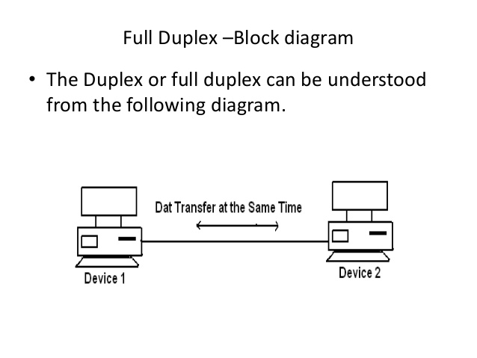

# Simplex, Half-Duplex, Full-Duplex, Unicast, Broadcast & Multicast -HSC

# Transmission media:-

* Transmission media is a communication channel that carries the information from the sender to the receiver. Data is transmitted through the electromagnetic signals.
* The main functionality of the transmission media is to carry the information in the form of bits through **LAN**(Local Area Network).
* It is a physical path between transmitter and receiver in data communication.
* In a copper-based network, the bits in the form of electrical signals.
* In a fibre based network, the bits in the form of light pulses.
* In **OSI**(Open System Interconnection) phase, transmission media supports the Layer 1. Therefore, it is considered to be as a Layer 1 component.
* The electrical signals can be sent through the copper wire, fibre optics, atmosphere, water, and vacuum.
* The characteristics and quality of data transmission are determined by the characteristics of medium and signal.
* Transmission media is of two types are wired media and wireless media. In wired media, medium characteristics are more important whereas, in wireless media, signal characteristics are more important.
* Different transmission media have different properties such as bandwidth, delay, cost and ease of installation and maintenance.
* The transmission media is available in the lowest layer of the OSI reference model, i.e., **Physical layer**.